**Hannah-Beth**

**Project 2 (HTML/CSS)**

**Responsive Design**

Link to Page:

<https://hannahhollywood.github.io/>

*(I’m currently still working on mobile responsive design of pages)*

**Features (Homepage):**

* Full Screen

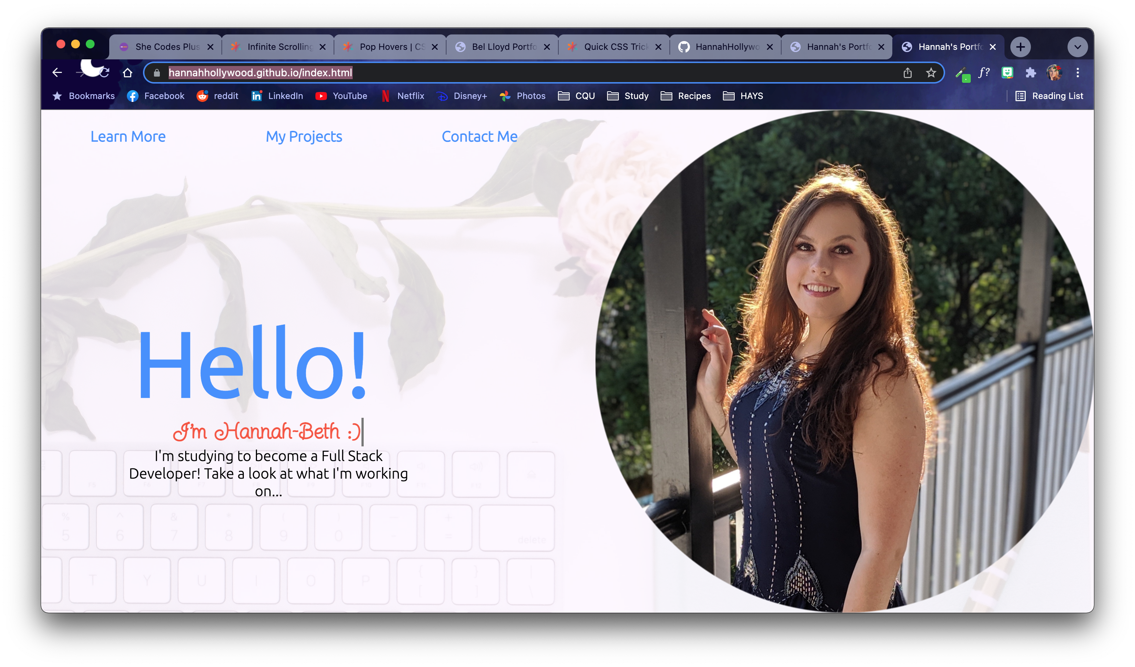

* Window Shrunk

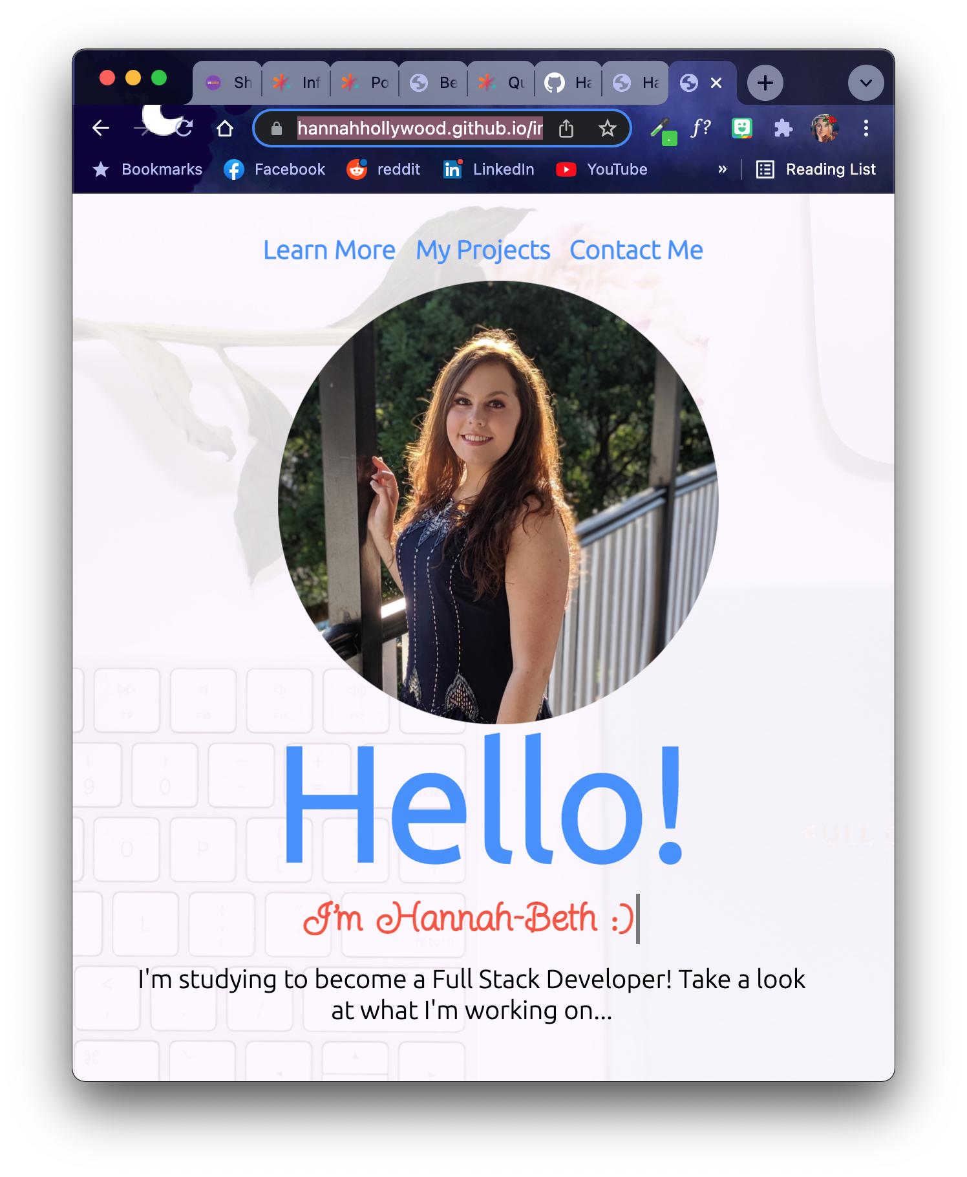

* JavaScript ‘typewriter’ which types out “I’m Hannah-Beth ☺”:

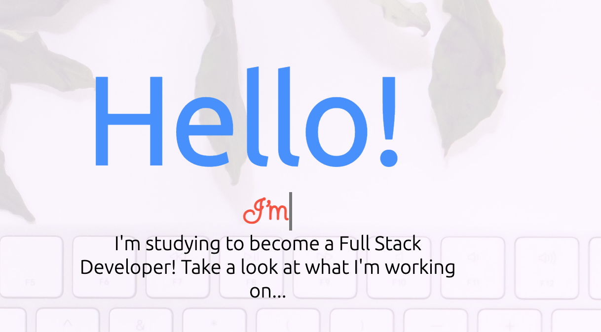

**Features (About Me):**

* Hover states (used on the page to highlight pictures)

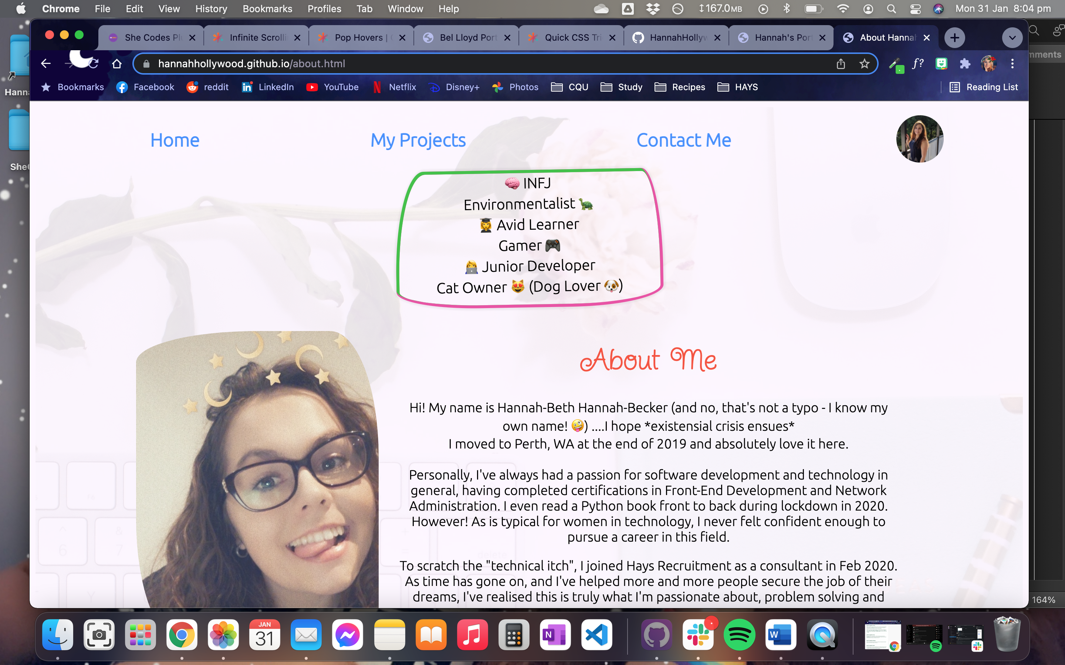 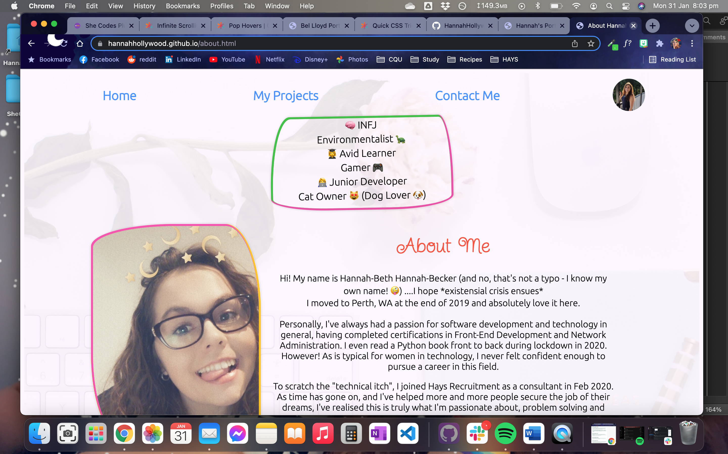

* Hover states (used to put coloured circles around links when people go to press on them)

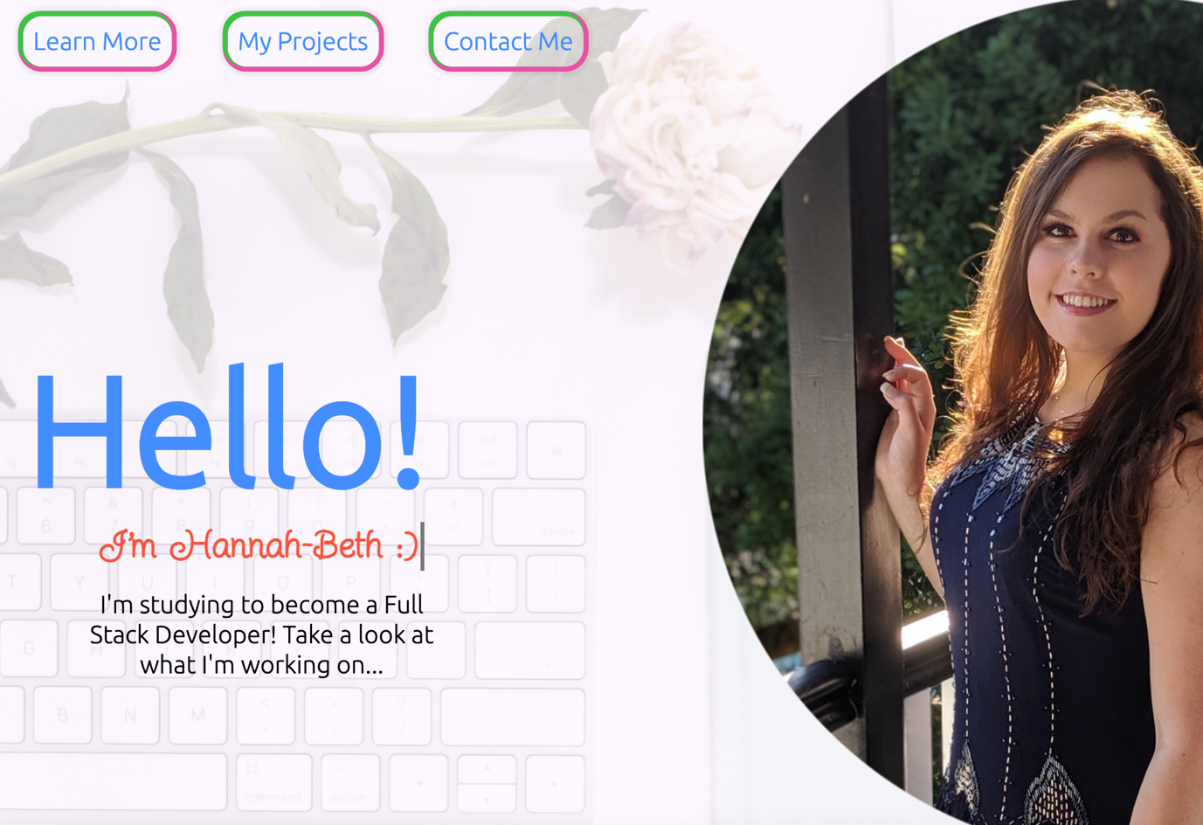

* Hover states (shuffling text-box downwards / upwards)

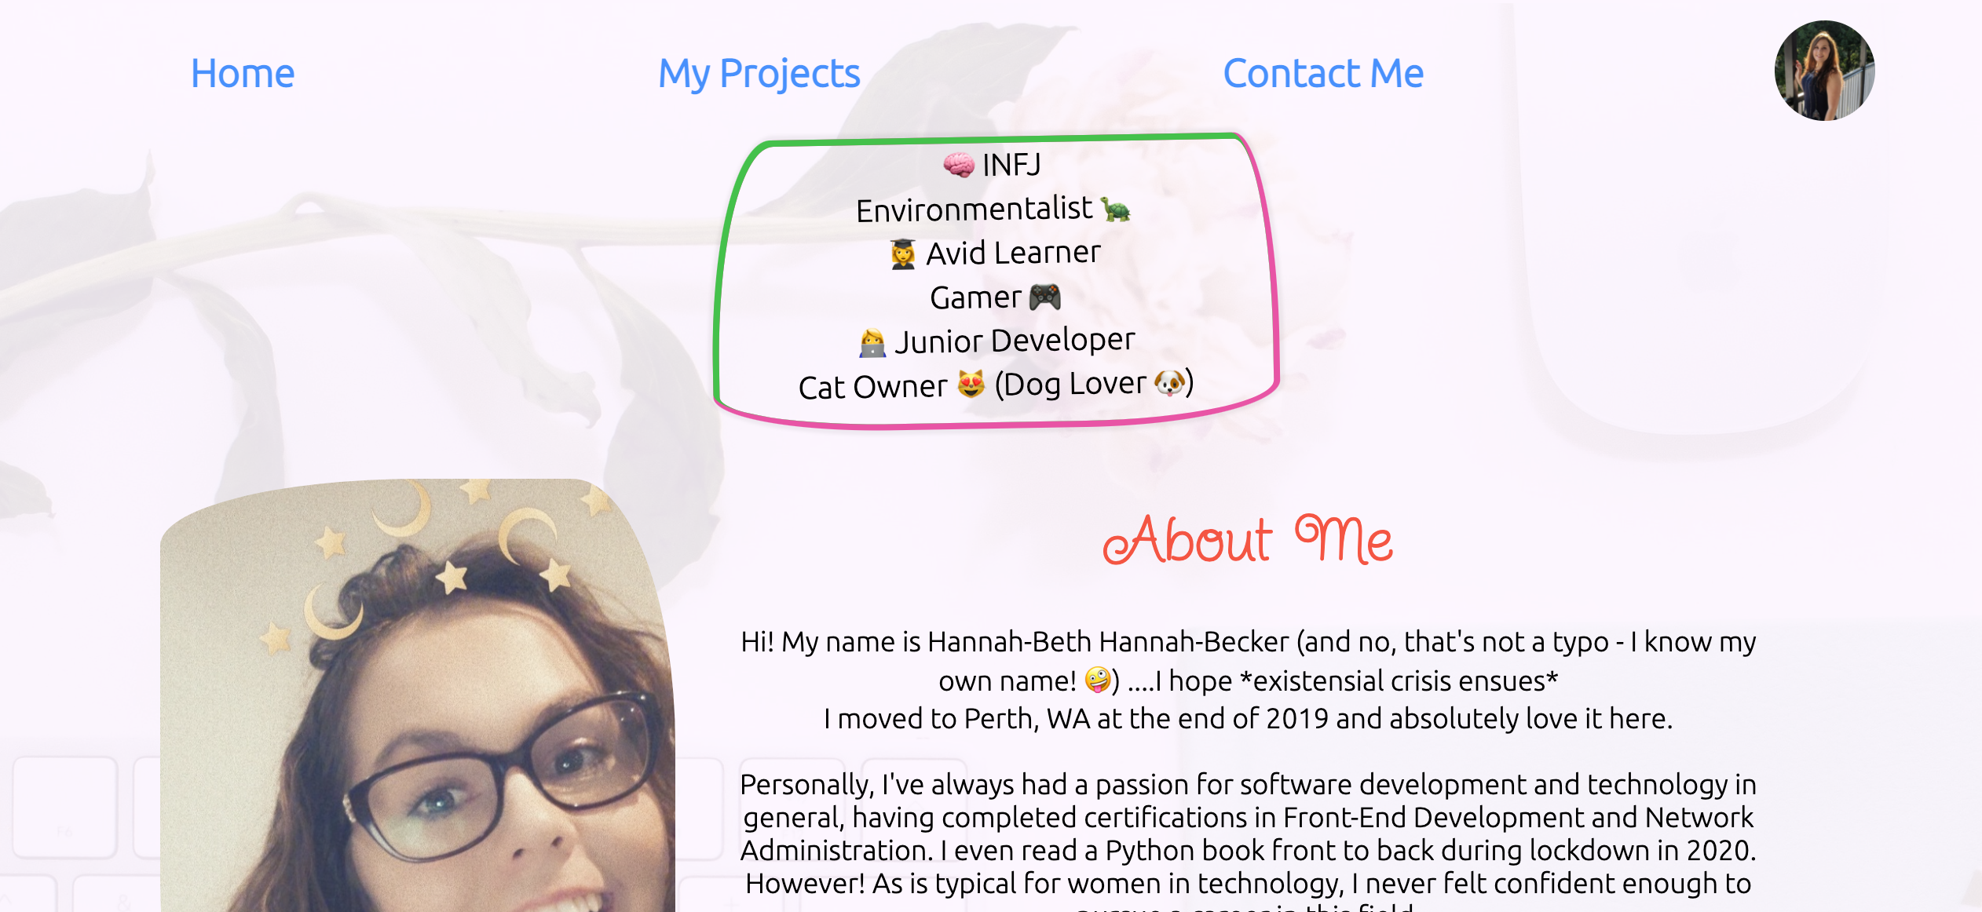 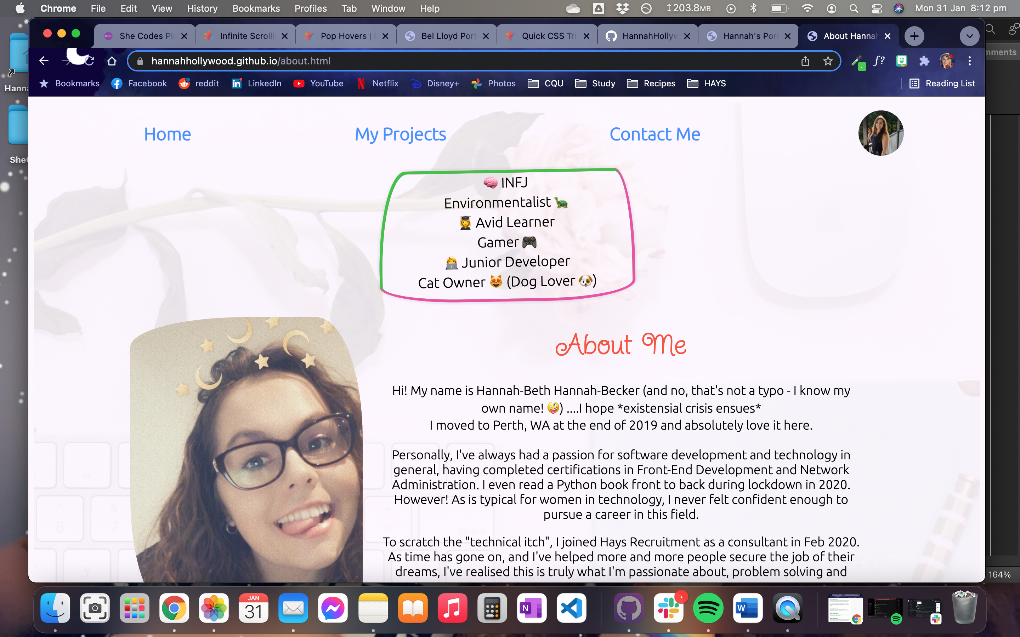

**Contact Me (Features):**

* Full Screen

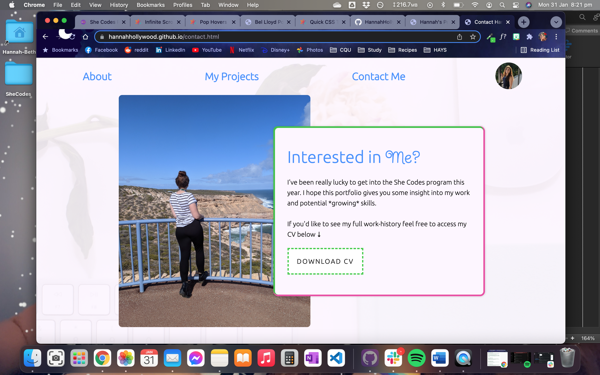

* Window Shrunk

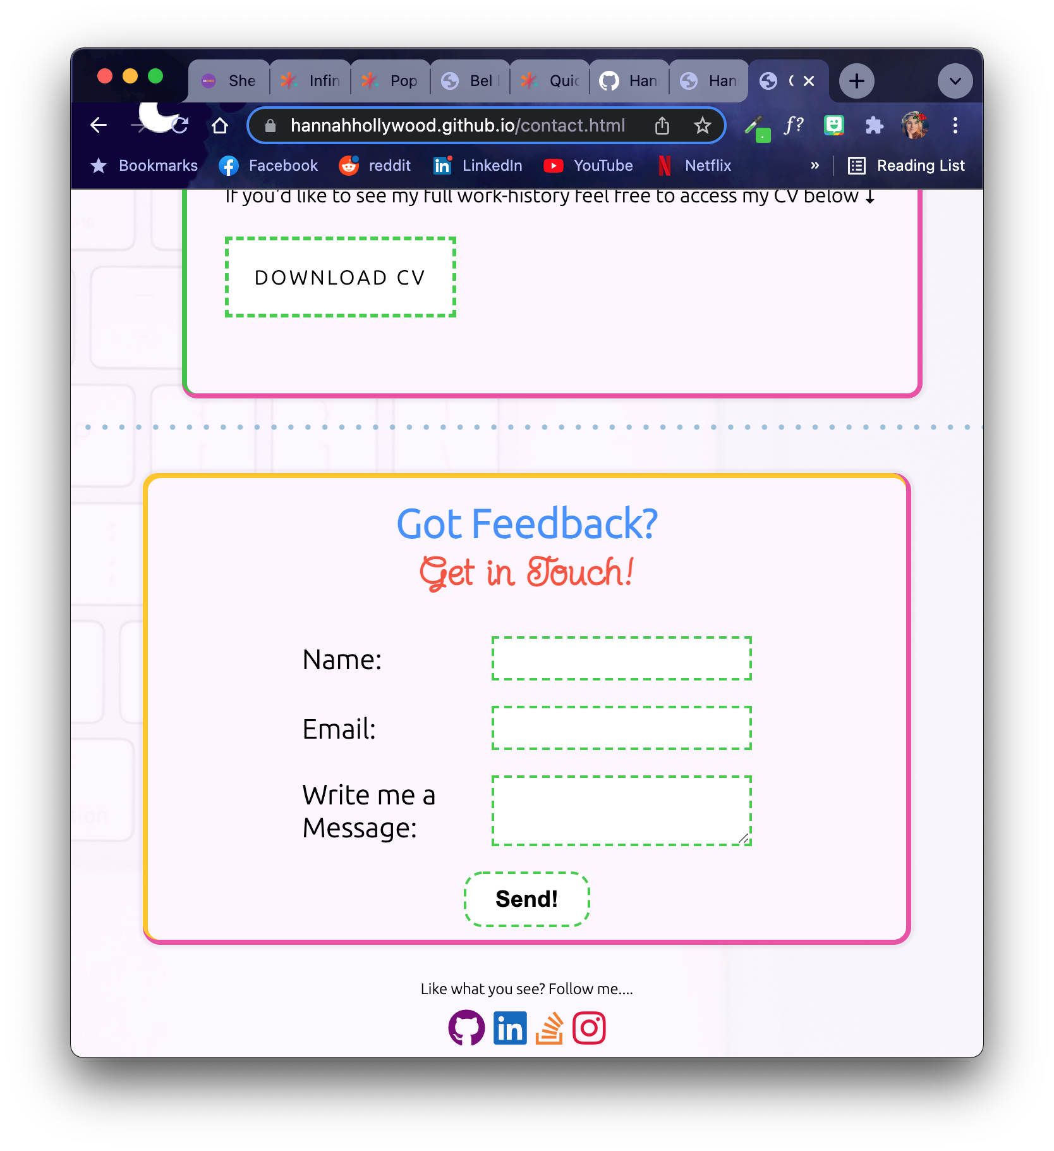

* Contact Form (with active hover state to move it upwards)

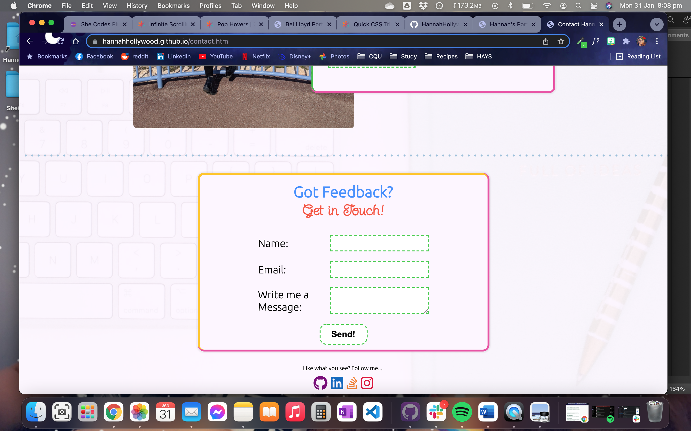 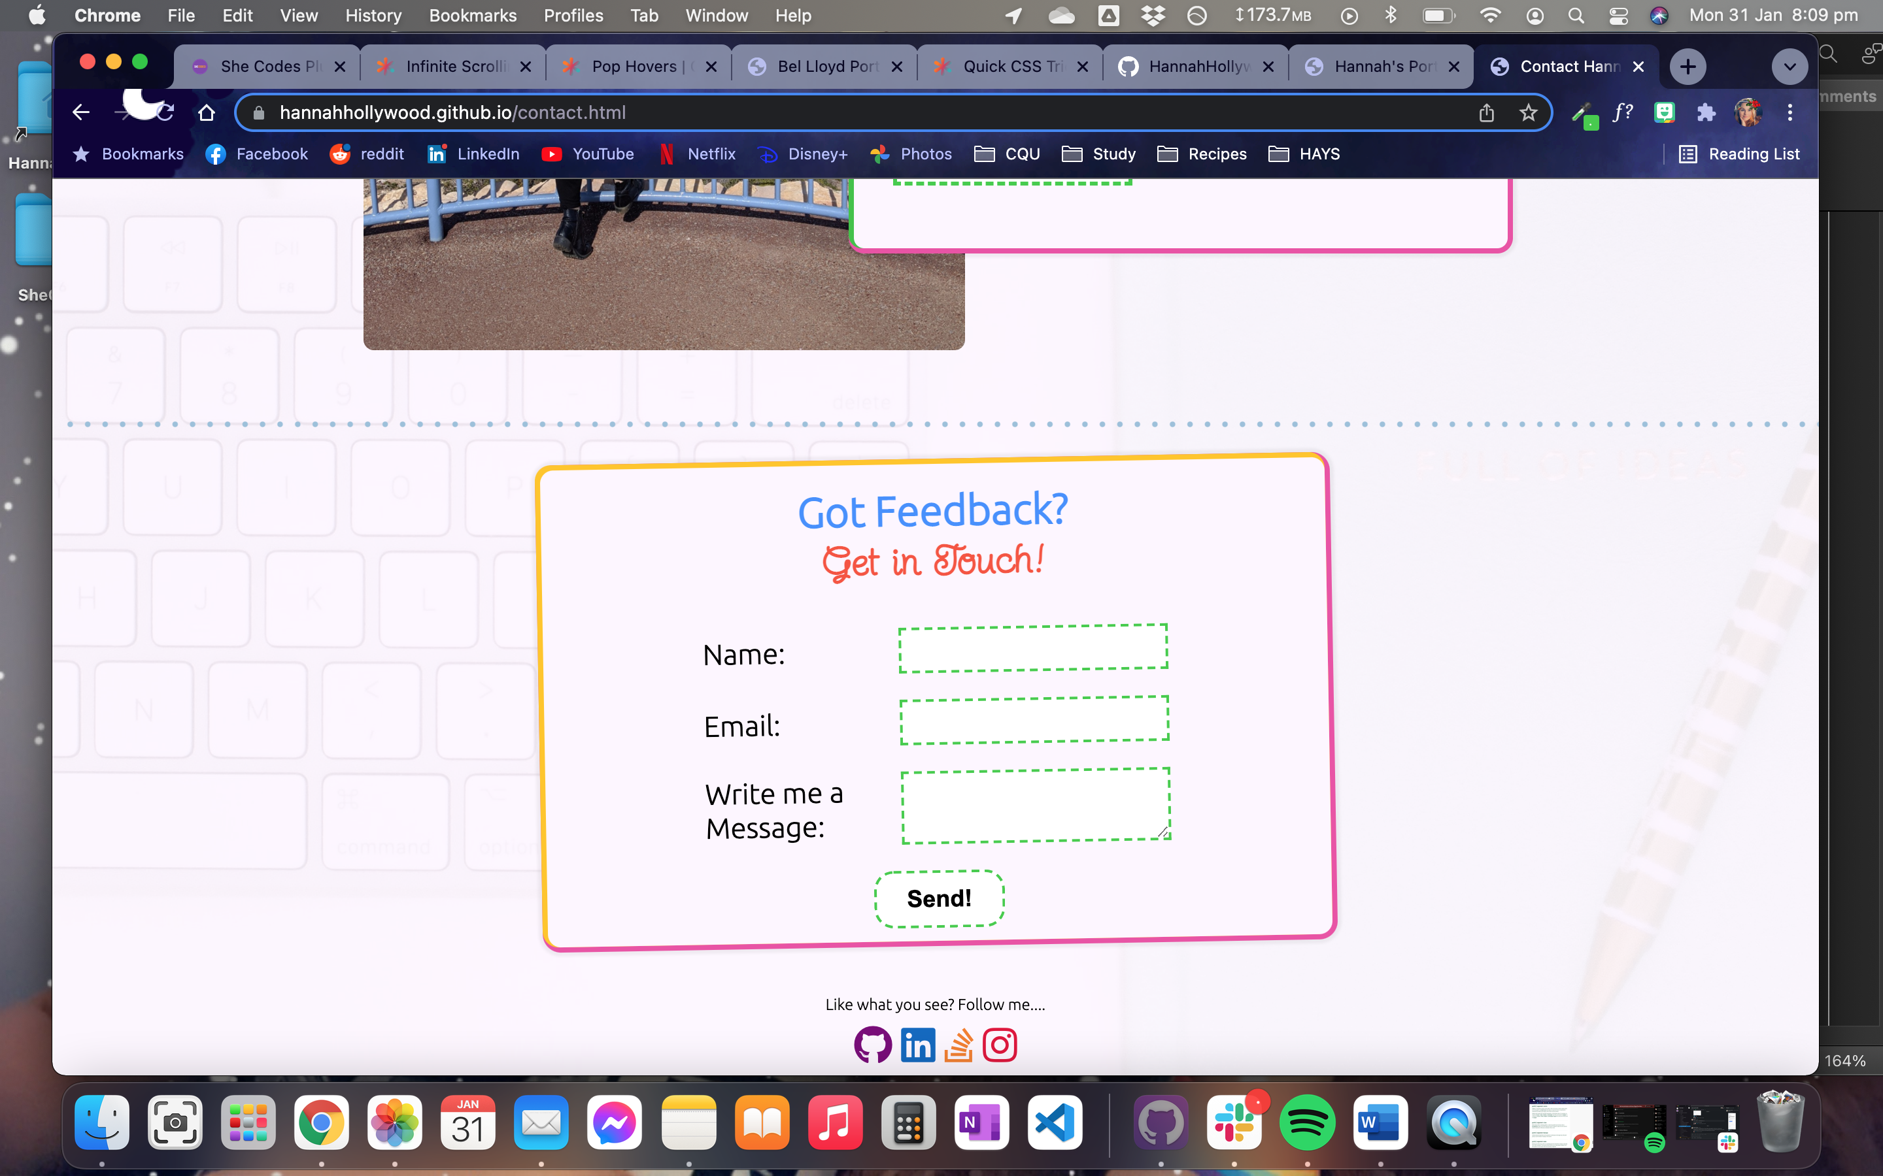

**Features (Projects Page):**

* Full Screen

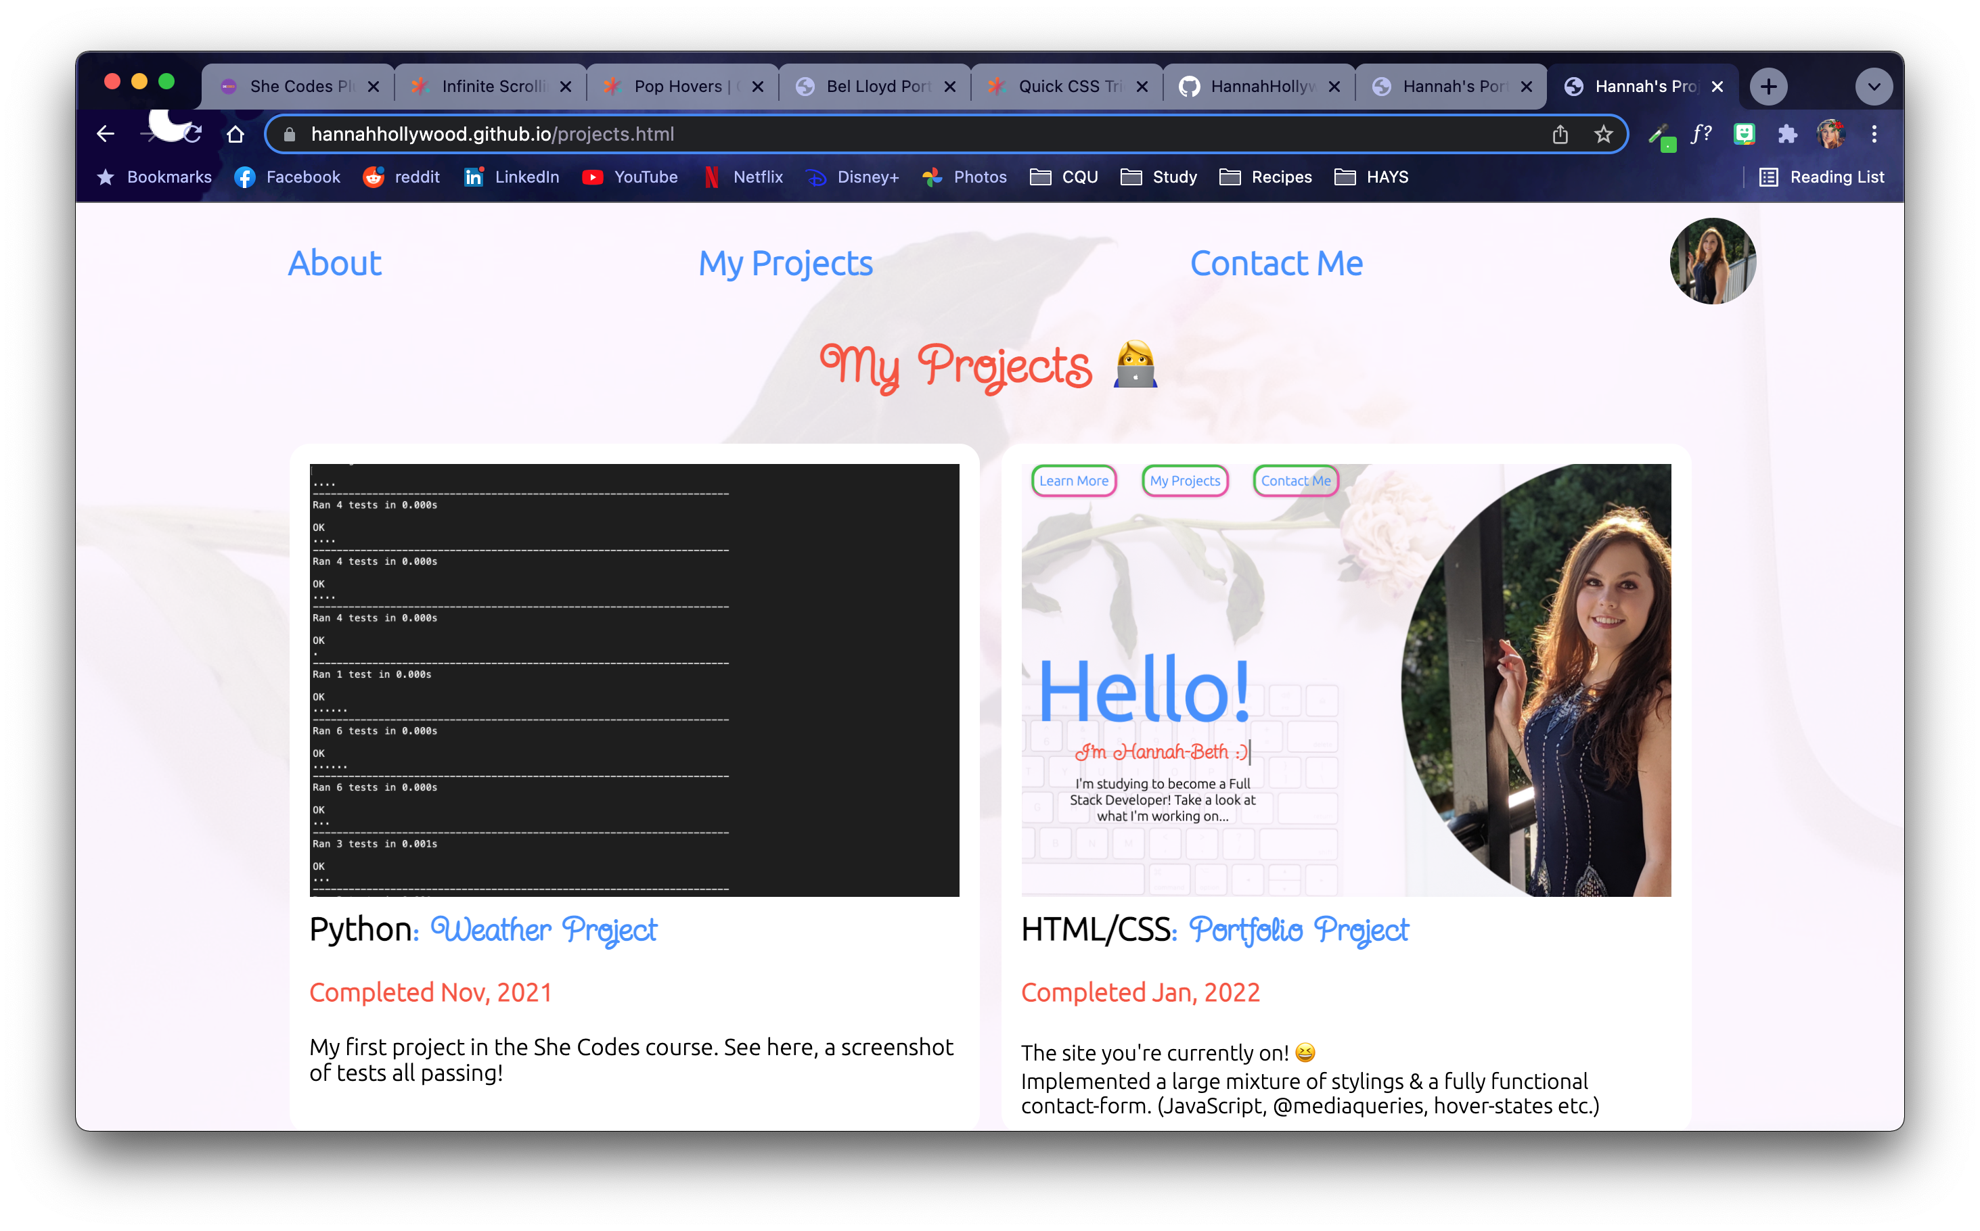

* Window Shrunk

